Lab 5.2. Calculate the tip

1. Before you begin

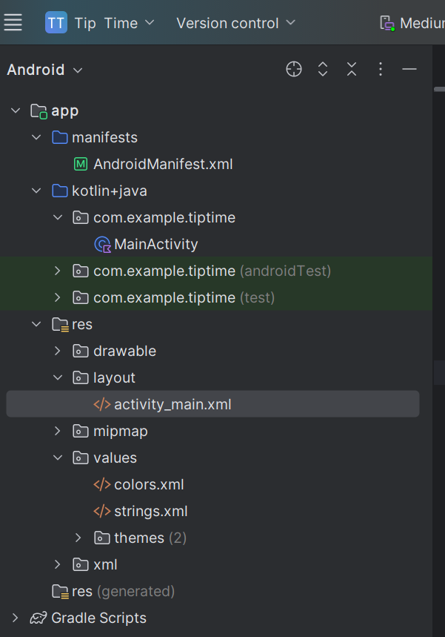

1. Starter app overview

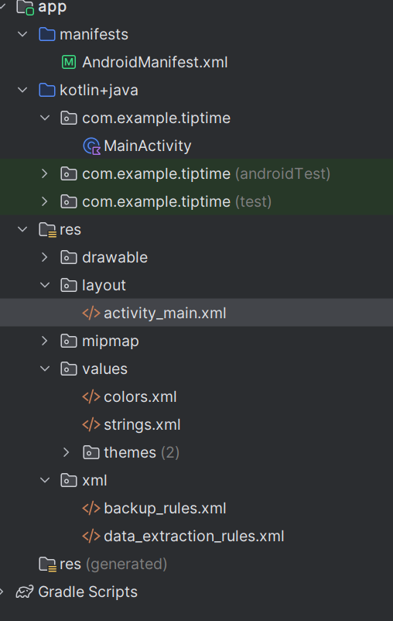

3. View binding

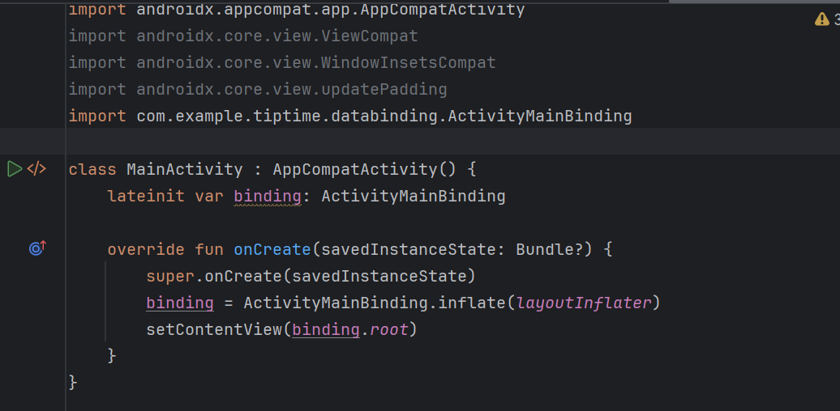

4. Calculate the tip

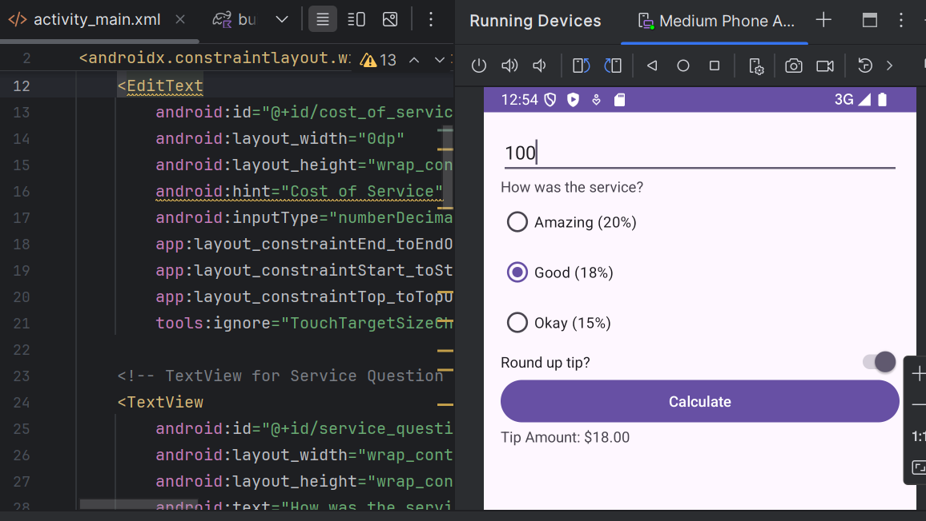

5. Test and debug

6. Adopt good coding practices